TECHPORCH INCORPORATED

DragON 1-Swipe Enrollment Guide
Step-by-Step Instructions for Setting Up Your Graphical Authentication
Product: DragON by Techporch Incorporated | Version 2.0

Table of Contents
- 1. Introduction
- 2. Prerequisites
- 3. Enrollment Steps
  - Step 1: Launch the Enrollment Application
  - Step 2: Enter Your Windows Credentials
  - Step 3: Credential Validation
  - Step 4: Select a Theme
  - Step 5: Create Your First Drag Sequence
  - Step 6: Understanding the LED Indicators
  - Step 7: Adding Additional Drag Sequences (Optional)
  - Step 8: Verify Your Drag Sequences
  - Step 9: Complete Enrollment
- 4. Important Notes

1. Introduction
DragON is a graphical authentication system developed by Techporch Incorporated that replaces or supplements traditional passwords with an intuitive visual "drag" gesture across themed image tiles. Instead of typing a password, you select a Start Tile and an End Tile from a themed grid of images — such as world landmarks, animals, space objects, ocean creatures, or cartoons — to create a unique drag sequence.
For stronger security, multiple drag sequences can be chained together. Each sequence acts as an additional layer of protection for your account.
This guide walks you through the enrollment process — the one-time setup that registers your drag sequences with the system. Once enrolled, you will use these drag sequences to log in to your Windows PC.

2. Prerequisites

Before You Begin
Please ensure you have the following ready before starting enrollment:

- A Windows PC with the DragON software installed
- A valid Windows username and password (or Microsoft account credentials)
- The dragEnroll.exe application, which is provided with your DragON installation

3. Enrollment Steps

Step 1: Launch the Enrollment Application
Navigate to your DragON installation folder and launch dragEnroll.exe. The enrollment window will appear displaying the Techporch branding and a credentials form where you will enter your Windows login information.

Figure 1 — The DragON enrollment login screen.

Step 2: Enter Your Windows Credentials
Fill in the following fields on the credentials form:
- User Name — Your Windows login username
- Domain/Computer Name — Your domain or local computer name (this is auto-populated in most cases)
- Password — Your Windows password
- Reenter Password — Confirm your Windows password by typing it again
If you are using a Microsoft account to sign in to Windows, check the box labeled "I am a Windows Live User."
Click Next to proceed. The application will validate your Windows credentials before continuing to the next step.

Tip
Make sure your Caps Lock key is off and that you enter your password exactly as you use it to log in to Windows.

Step 3: Credential Validation
The application validates your Windows credentials against the system. If your credentials are correct, you will automatically proceed to the theme and tile selection screen.
If credential validation fails, you will see an error message. In that case, re-enter your username and password carefully, and click Next again to retry.

Step 4: Select a Theme
Once your credentials are validated, you will be presented with a set of tile themes to choose from. Select the theme that appeals to you — this determines the images that will appear in your tile grid. Available themes include:

Theme | Description
Landmarks | Famous world landmarks such as the Eiffel Tower, Taj Mahal, Statue of Liberty, and more
Animals | Illustrations of animals from around the world
Space | Space and astronomy imagery including planets, stars, and galaxies
Ocean | Ocean and marine life images
Cartoon | Cartoon characters and illustrations

Additional themes may be available depending on your installation. After selecting a theme, the tile grid will populate with images from that theme.
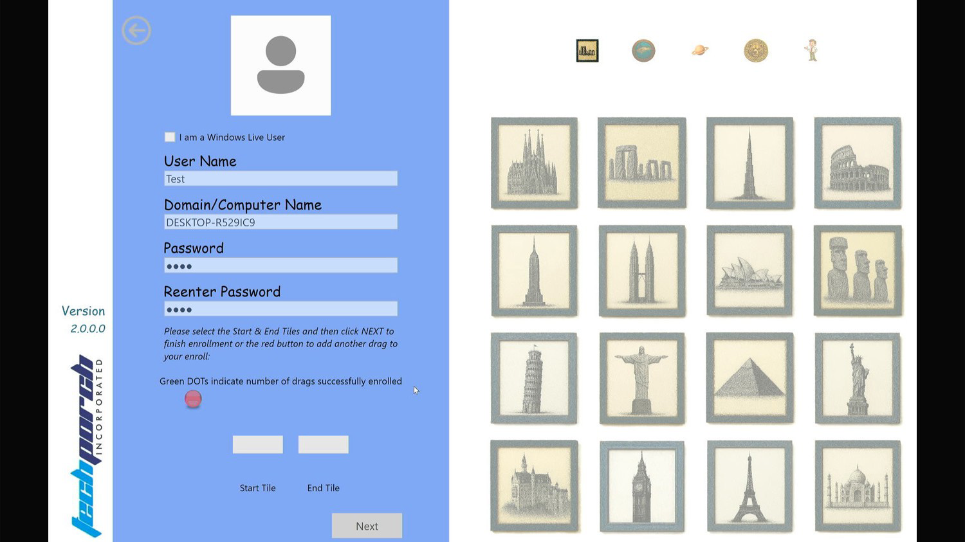
Figure 2 — The tile grid populated with Landmarks theme images.

Step 5: Create Your First Drag Sequence
This is the core of DragON enrollment — you will now select your Start Tile and End Tile to create your unique drag sequence.
- Select the Start Tile — Click on any image tile from the grid. This becomes your starting point. The selected tile will appear in the "Start Tile" slot on the left panel of the application.
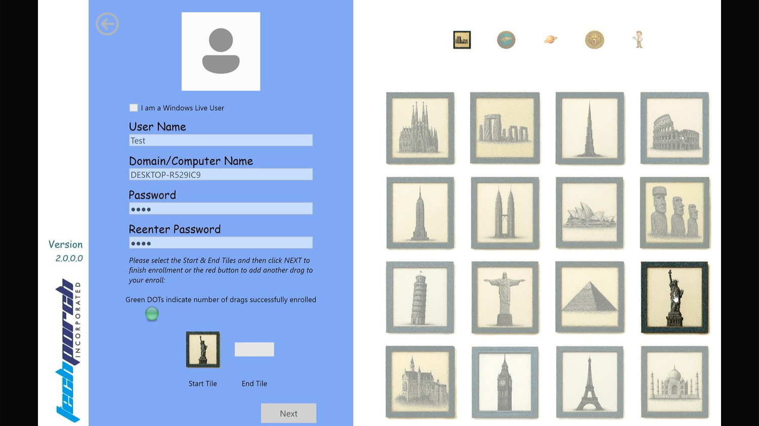
Figure 3 — Selecting the Start Tile (Statue of Liberty highlighted).
- Select the End Tile — Click on a different image tile from the grid. This becomes your ending point. The selected tile will appear in the "End Tile" slot on the left panel.

Tip
Choose tiles that are personally meaningful and easy for you to remember, but not obvious to someone who knows you. Avoid selecting the first two tiles or tiles that are right next to each other.

Step 6: Understanding the LED Indicators
The LED indicators on the left panel of the application show the status of your drag sequences:

LED Color | Meaning
RED | Indicates which drag sequence is currently being set up (active sequence)
GREEN | Indicates a drag sequence has been successfully configured

Once both a Start Tile and an End Tile are selected for a drag sequence, the corresponding RED LED turns GREEN, confirming that sequence is complete.
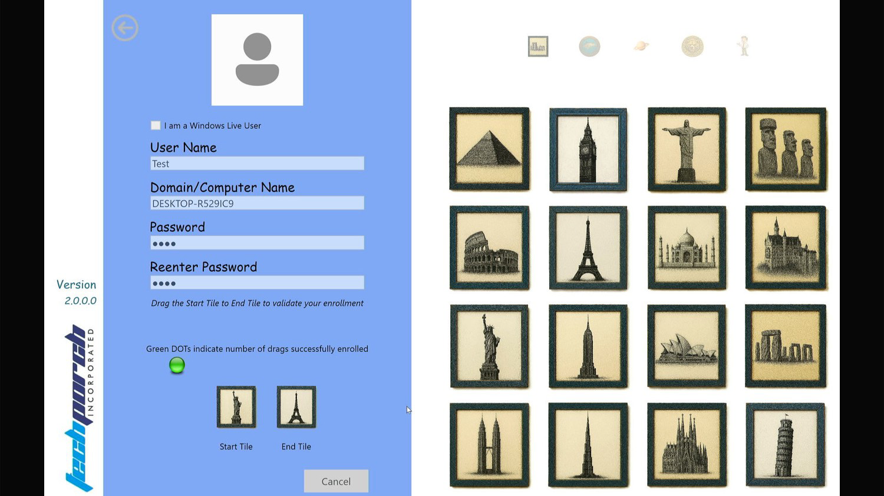
Figure 4 — A green LED indicator confirms the first drag sequence is complete.

Step 7: Adding Additional Drag Sequences (Optional)
For stronger security, you can add multiple drag sequences. Each additional sequence acts as another layer of authentication. To add more sequences:
- After your first drag sequence turns GREEN, look for the next RED LED indicator below it.
- Click on the RED LED (the one immediately after the current GREEN LED) to begin setting up a second drag sequence.
- Select a new Start Tile and a new End Tile for this second sequence.
- The second LED will turn GREEN once the selection is complete.
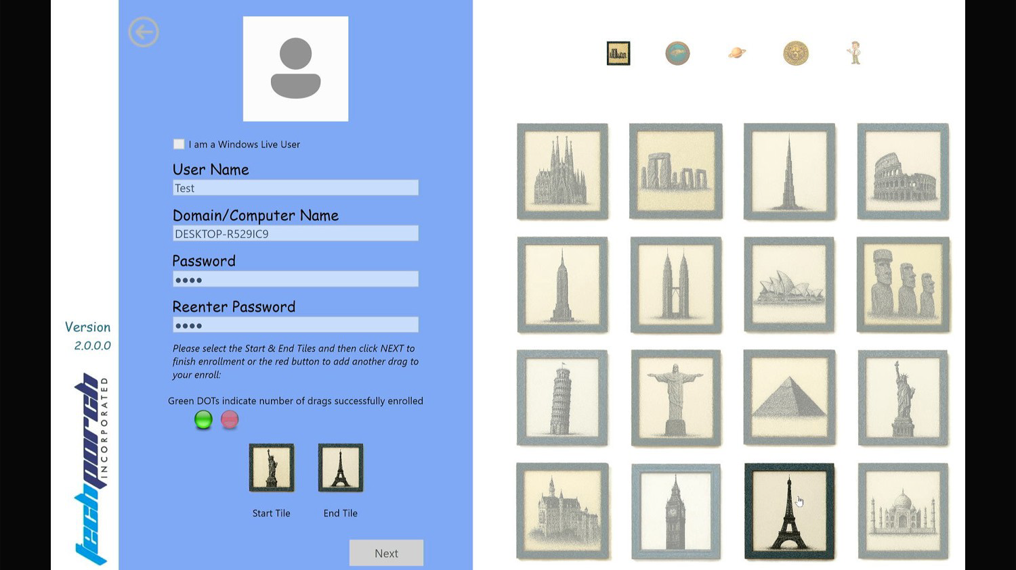
Figure 5 — Two green LEDs indicate two completed drag sequences.
- Repeat this process to add as many drag sequences as desired.
- When you are satisfied with the number of sequences, click Next to proceed to verification.

Important
Remember the exact order in which you created your drag sequences. You will need to repeat them in the same order during verification and every time you log in.

Step 8: Verify Your Drag Sequences
The enrollment process will now ask you to verify all drag sequences you set up, in the exact same order you created them.
- Perform each drag sequence (Start Tile → End Tile) in the order you created them.
- If you select the wrong tile or enter the wrong sequence, do not worry — simply restart from the first sequence again.
- Once you have successfully completed all sequences in the correct order, the enrollment validation is complete.

Tip
Take your time during verification. There is no time limit. Focus on accuracy rather than speed.

Step 9: Complete Enrollment
Once all drag sequences are verified successfully, you will see a confirmation screen. Click Done to save your enrollment data.
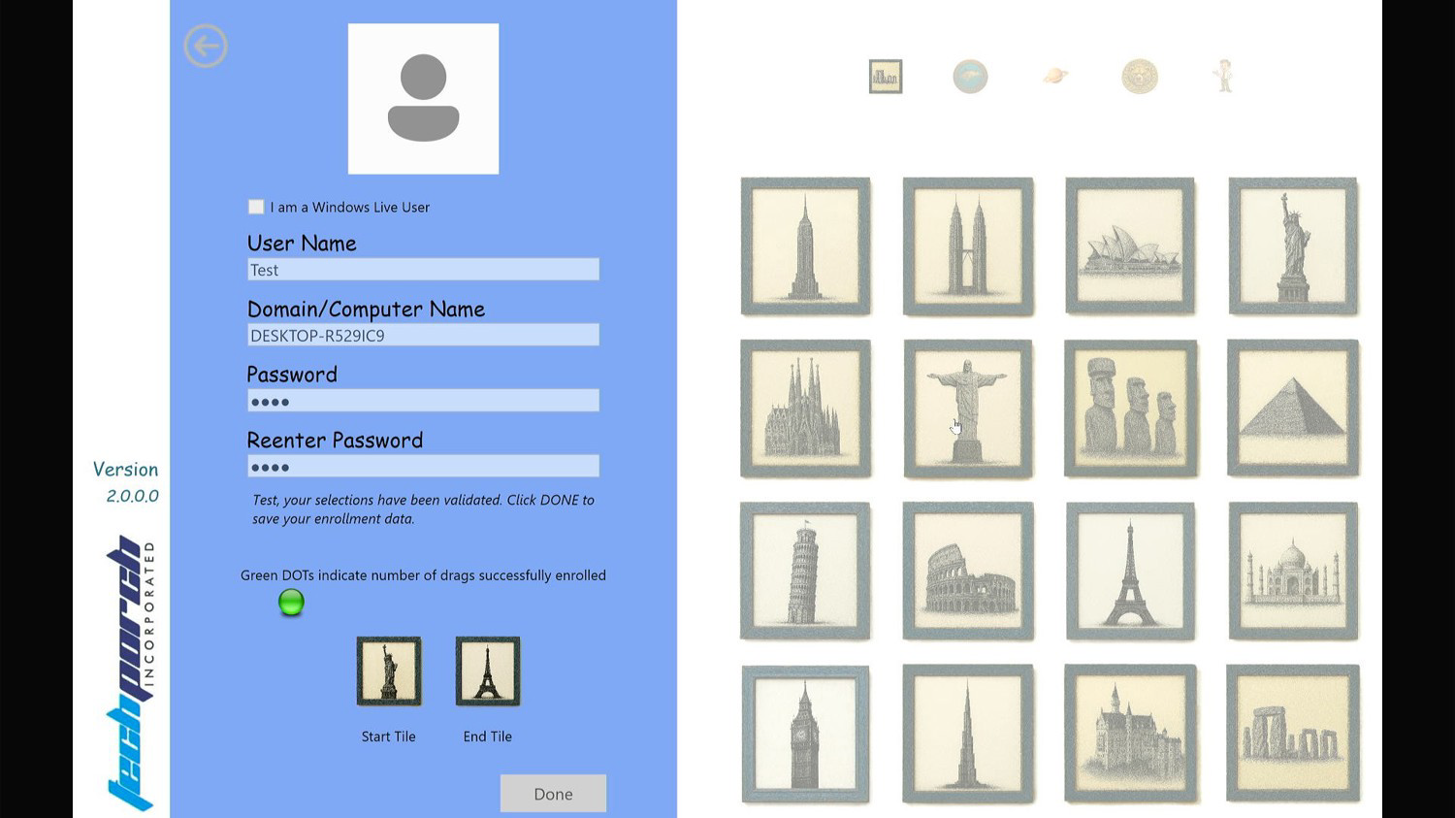
Figure 6 — Enrollment complete. Click "Done" to save your settings.
Congratulations — your DragON enrollment is now complete! The next time you log in to Windows, you can use your drag sequences to authenticate instead of typing a traditional password.

4. Important Notes

Trial Version Limitation
If you are using a TRIAL version of DragON, you will be limited to 1 drag sequence only. Upgrade to the full version to unlock multiple drag sequences for enhanced security.

Tips for Strong Security
• Choose tiles that are memorable to you but not obvious to others.
• Use 2 or more drag sequences for stronger protection.
• Your drag sequences are order-sensitive — the order you create them is the order you must enter them during login.
• Do not share your tile selections with anyone.

Troubleshooting
• Credential validation fails: Verify that your Windows username and password are correct. Ensure Caps Lock is off and that you are entering the correct domain or computer name.
• Mistake during verification: Simply restart the verification from the first drag sequence. You do not need to re-enroll.
• Need further help: Contact Techporch support at www.Techporch.com for additional assistance.

© Techporch Incorporated. All rights reserved.
www.Techporch.com
Version 2.0

